**2023-2027 Batch**

**AIM**: Implement the concept of Normal Distribution by using the MATLAB Program.

# OBJECTIVE:

* Understanding the theoretical foundation of Normal Distribution
* Practical application of Normal Distribution in MATLAB
* Working with real world data
* Visualizations (If applicable)

# INTRODUCTION

The **Normal Distribution**, also known as the **Gaussian distribution**, is a continuous probability distribution that is symmetric about the mean. It is defined by two parameters:

• **Mean (μ)**: Determines the center of the distribution.

• **Standard Deviation (σ)**: Controls the spread or dispersion of data.

The probability density function (PDF) of a normal distribution is given by:

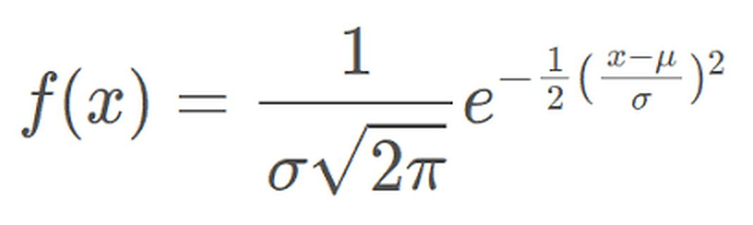

where:

• x is the variable,

• μ is the mean,

• σ is the standard deviation,

• π and e are mathematical constants.

**Properties of Normal Distribution**

1. The curve is symmetric around the mean μ.

2. The total area under the curve is equal to 1.

3. About **68%** of the data falls within **one standard deviation** (μ ± σ).

4. About **95%** of the data falls within **two standard deviations** (μ ± 2σ).

5. About **99.7%** of the data falls within **three standard deviations** (μ ± 3σ).

**PROBLEM 1:** A university exam follows a normal distribution with a **mean** of 70 and a **standard deviation** of 10. What is the probability that a randomly selected student scores **above 85**?

**Solution:**

We need to find: P(X > 85) = 1 - P(X <= 85)

Using the cumulative distribution function (CDF) in MATLAB, we can solve this.

# MATLAB CODE

% Given parameters

mu = 70; % Mean

sigma = 10; % Standard Deviation

x = 85; % Score threshold

% Calculate the probability using the normal cumulative distribution function

prob = 1 - normcdf(x, mu, sigma);

% Display the result

disp(['The probability that a student scores above 85 is: ', num2str(prob)]);

% Visualization

x_vals = 40:0.1:100; % Range of scores

y_vals = normpdf(x_vals, mu, sigma); % PDF values

% Plot the normal distribution

figure;

plot(x_vals, y_vals, 'b', 'LineWidth', 2);

hold on;

area(x_vals(x_vals > x), normpdf(x_vals(x_vals > x), mu, sigma), 'FaceColor', 'r', 'FaceAlpha', 0.5);

xlabel('Score');

ylabel('Probability Density');

title('Normal Distribution of Exam Scores');

legend('PDF', 'P(X > 85)');

grid on;

hold off;

**OUTPUT:** The probability that a student scores above **85** is approximately **0.0668 (6.68%)**.

**VISUALIZATION:**

• The blue curve represents the **probability density function (PDF)**.

• The red shaded region represents **P(X > 85)**.

**PROBLEM 2: This visualization shows the normal distribution of rod lengths, highlighting the probability of rods being defective (less than 47 cm or greater than 53 cm) in red.**

# MATLAB CODE:

# % Given parameters

# mu = 50; % Mean

# sigma = 2; % Standard Deviation

# x1 = 47; % Lower defect threshold

# x2 = 53; % Upper defect threshold

# % Generate values for plotting

# x_vals = 40:0.1:60;

# y_vals = normpdf(x_vals, mu, sigma);

# % Plot the normal distribution

# figure;

# plot(x_vals, y_vals, 'b', 'LineWidth', 2);

# hold on;

# area(x_vals(x_vals < x1), normpdf(x_vals(x_vals < x1), mu, sigma), 'FaceColor', 'r', 'FaceAlpha', 0.5);

# area(x_vals(x_vals > x2), normpdf(x_vals(x_vals > x2), mu, sigma), 'FaceColor', 'r', 'FaceAlpha', 0.5);

# xlabel('Rod Length (cm)');

# ylabel('Probability Density');

# title('Normal Distribution of Rod Lengths');

# legend('PDF', 'Defective Rods');

# grid on;

# hold off;

**VISUALIZATION:**

**• A blue bell-shaped curve, representing the normal distribution of rod lengths.**

**• Red shaded areas at both ends of the curve, representing defective rods:**

**• Left side (X < 47 cm)**

**• Right side (X > 53 cm)**

**• The plot will show that most rods fall within the acceptable range, but some (in red) are defective.**